Signage template for Crown land managers

The following signage template has been developed by the Department of Planning, Housing and Infrastructure – Crown Lands, for use by Crown land managers (CLMs).

CLMs should refer to the signage and compliance guidance information on the Reserve Manager website to assist in the production of signs for use on Crown reserves. This guidance material is available at:

- Signage - https://www.crownland.nsw.gov.au/reserve-manager/managing-reserves/signage
- Compliance - https://www.crownland.nsw.gov.au/reserve-manager/managing-reserves/compliance-matters

Instructions for using the template:
- The following technical requirements must be applied to Crown land signage:
  - ‘CROWN LAND’ in banner or heading at the top of or at the bottom of the sign
  - display of the NSW Government waratah logo
  - use of clear unambiguous language
  - your own logo and/or any other distinctive or individual requirements of the reserve
  - CLM contact details such as phone number, email address and/or website.

Note: Technical requirement 1a does not apply to Surveillance, Danger or Warning signs.

- Provide the following completed template to your preferred signwriter for production

- If the sign is for regulatory purposes (such as for prohibited activities and/or where penalties may apply), you may send the draft sign for review by the department via the contact details listed below.

Assistance
For further assistance regarding the development of signage, please contact the Department via telephone on 1300 886 235 or email at: cl.compliance@crownland.nsw.gov.au
Crown Lands

THE FOLLOWING ARE NOT PERMITTED

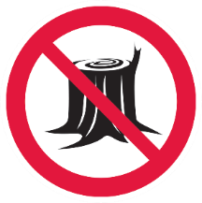 | 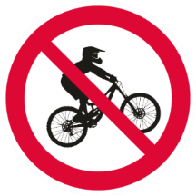 | 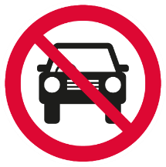
CUTTING TREES OR  REMOVING TIMBER | TRAIL BIKES | UNAUTHORISED VEHICLES
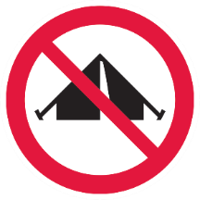 | 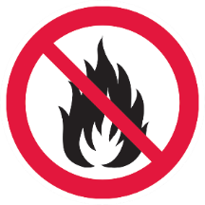 | 
CAMPING OR  RESIDING | FIRES | LITTERING  DUMPING RUBBISH OR MATERIALS


PENALTIES APPLY
INSERT CONTACT DETAILS
PHONE/WEBSITE

